Uploading files into GitHub

You can install SourceTree on supported Microsoft Windows or OS X operating systems.

Before you set up SourceTree, you need a Bitbucket account. You can create it now or you can create it later during the SourceTree registration process. Use your VA email to create the Bitbucket account.

* For more information on creating a Bitbucket account, see <https://bitbucket.org/account/signup/>

### Downloading and installing SourceTree client

1. Visit the SourceTree URL: <https://www.sourcetreeapp.com/>
2. Choose **Download for Windows**, agree to the Atlassian license agreement and save the app to your local downloads folder. (example: use downloads folder or create a SourceTree folder on C: drive, c:/users/vhaiswrussem/SourceTree
3. In your computer's folder, double-click on the **SourceTree app, (SourceTreeSetup-3.3.8).** Note: you may have to try a few times.
4. You can create the Bitbucket account now if you don’t have it by clicking on “create one for free”. Use your *VA email address* to create the account. If you already have an account, then click on “Bitbucket box” and **select** “use an existing account”.
5. An email will be sent to your VA email inbox. Once received, click on verify your email. You will be redirected to enter a unique name for the Bitbucket Cloud (no spaces). You will fill out a brief survey.

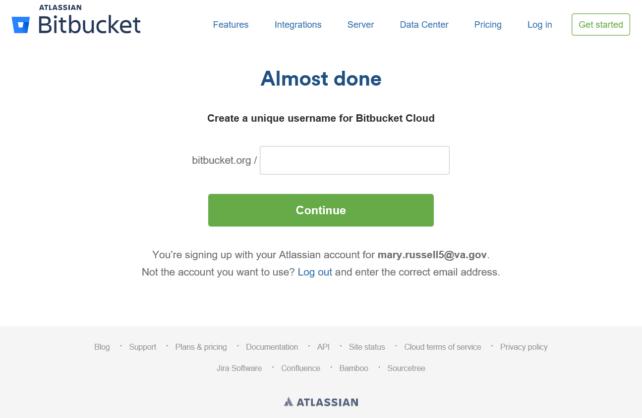

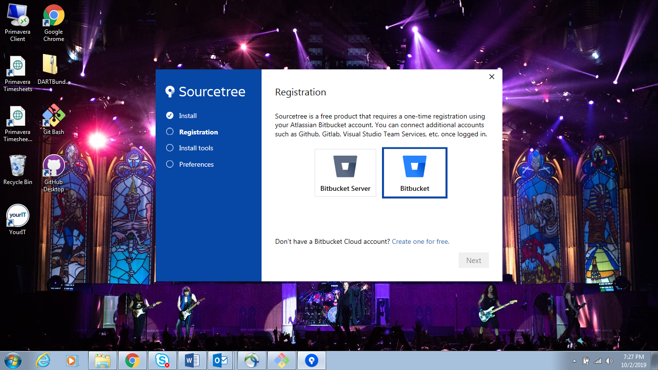

### This will open a browser and you must enter the bitbucket account information.

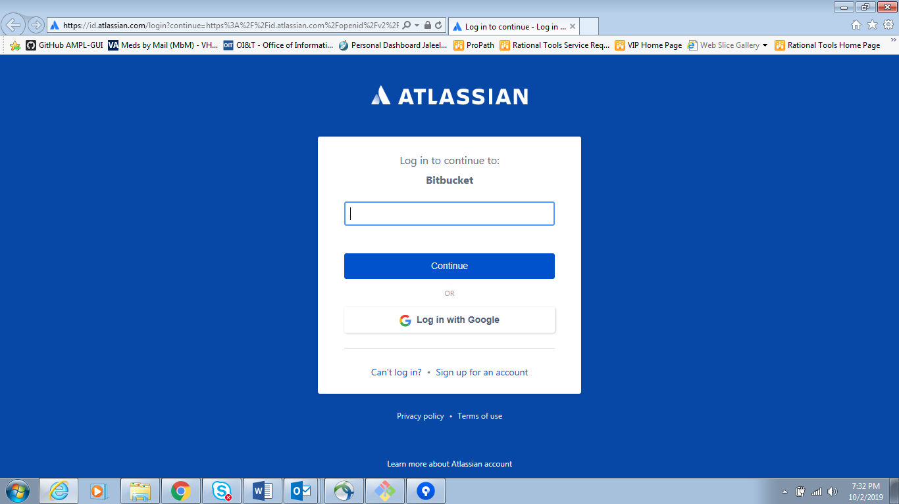

1. Confirm access to your account by clicking “**Grant access**” tab.
2. Registration Complete. Click “**Next**” and pick tools to download and install. Git will be discovered automatically. **Unclick** the checkbox for Mercurial. Hit “**Next**”.

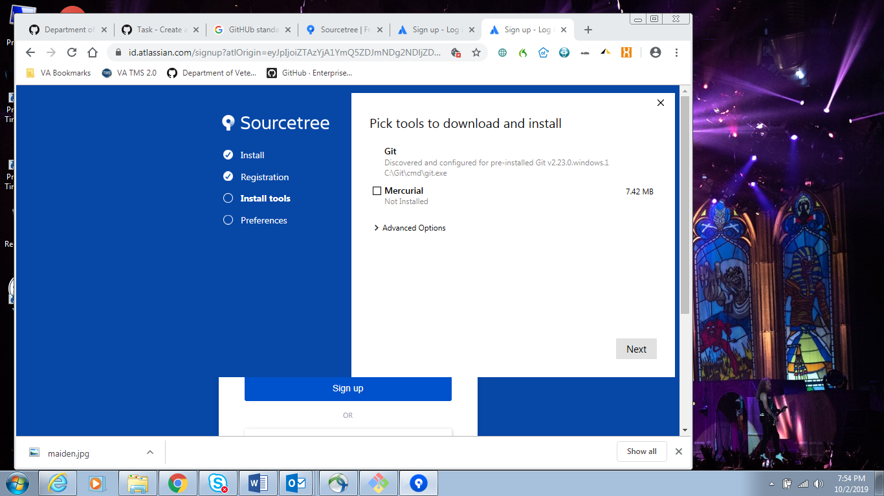

1. Under **Preferences**, click the checkbox to set global details for Git and enter your user name and email address. Click **Next**

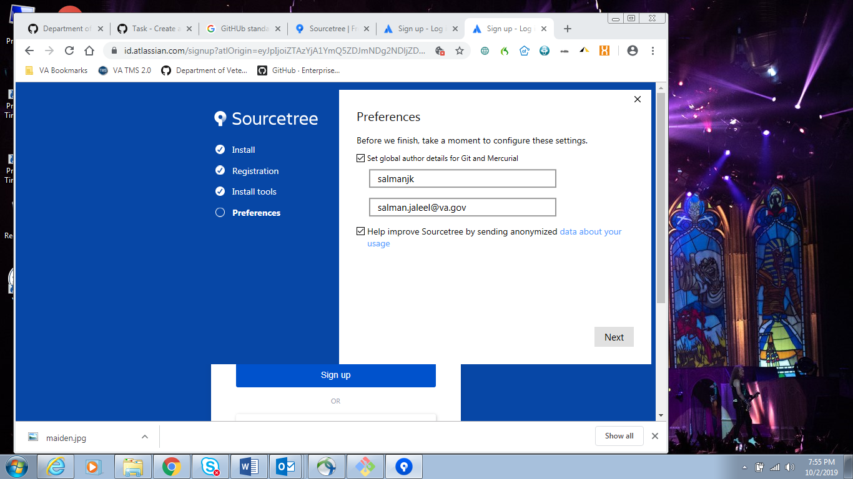

### It will prompt to load SSH key. Click **No**

1. SourceTree GUI opens, if you see you account on the left pane you are **FINISHED.**

If you don’t see your account on the left pane, proceed with the following:

1. Click “**Edit Accounts**”, select hosting service as **GitHub** from the dropdown menu, specify the Host URL: <https://github.com> Preferred Protocol: **HTTPS**. Under credentials, select **OAuth** from the Authentication drop down menu and click “**Refresh OAuth Token**”.
2. It will take you to GitHub.com. Enter your GitHub username and password.

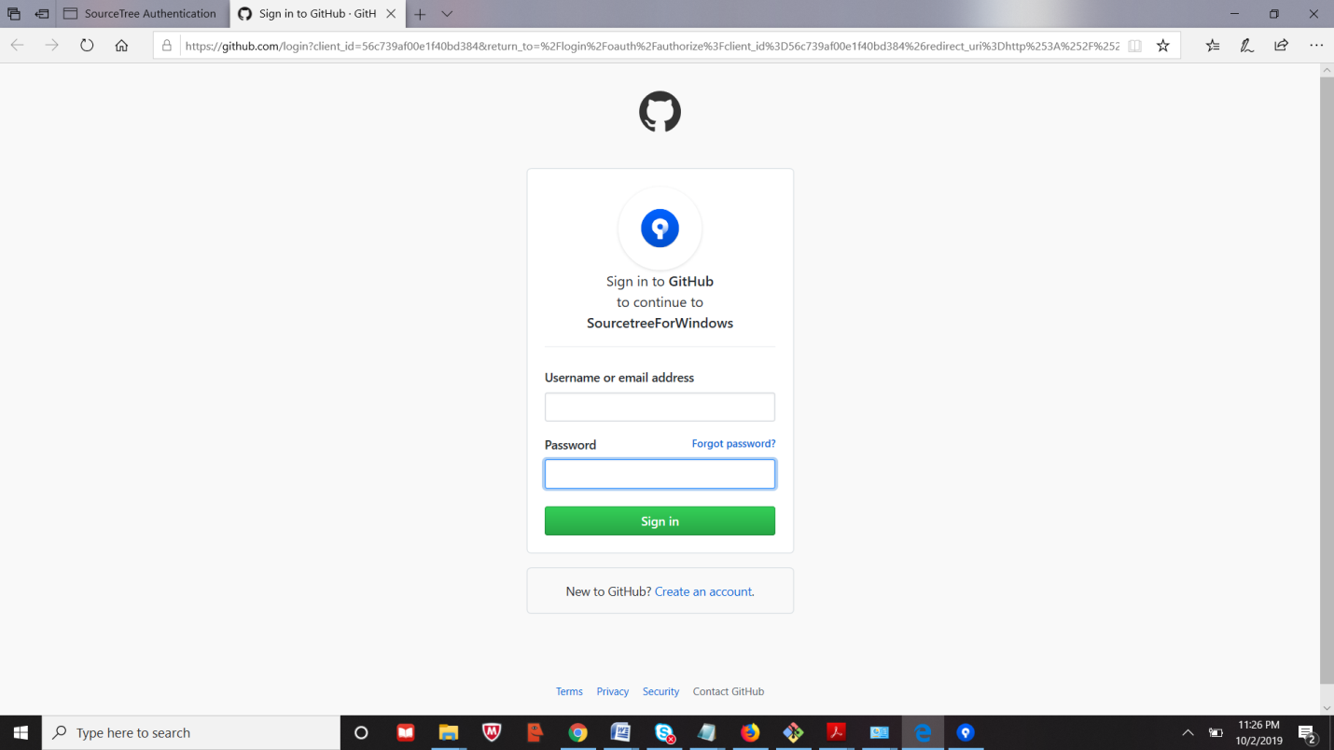

1. Authorize SourceTree for Windows by clicking on the **Authorize Atlassian** button below.
2. **Go back** to the SourceTree GUI and click OK.

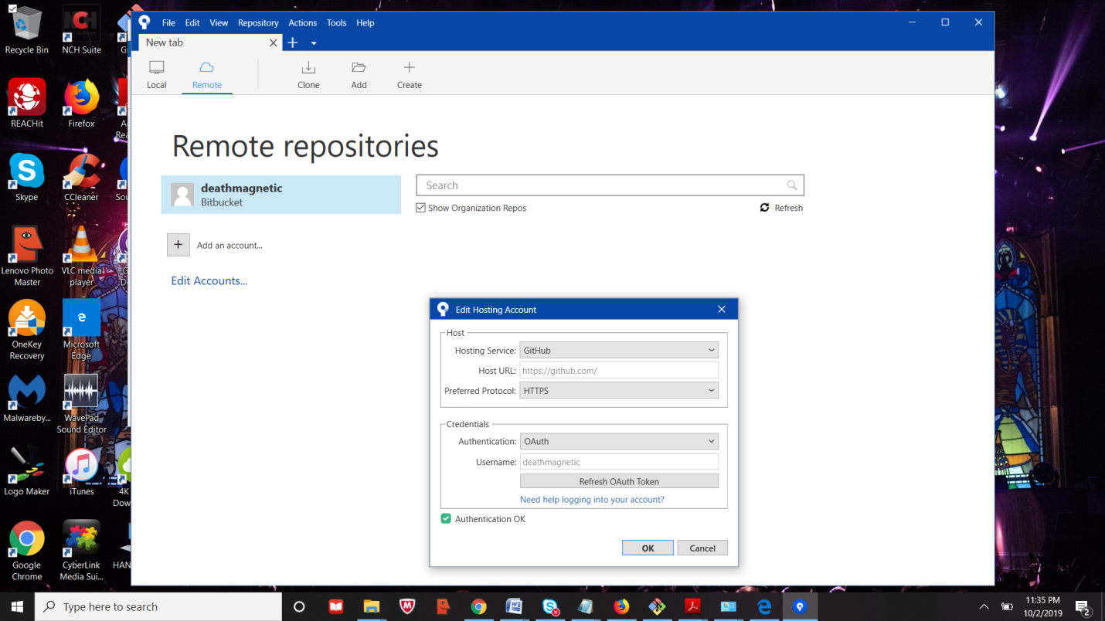

1. You will see your account appear on the left with your repositories on the right. You can now clone a repository by clicking “**Clone**”.